**Create table RealEstate :**

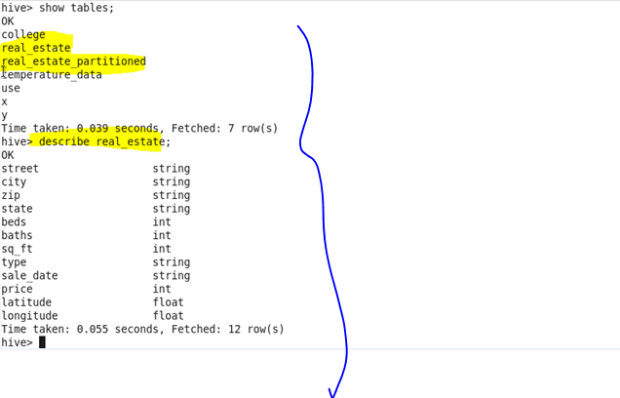

**Load dataset into table:**

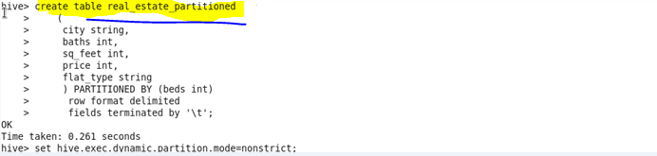

**Using Dynamic partition get separate lists of residential apartments with more than 2 beds and include columns in following order City,Baths,Sq_feet,Price,flat_type,Beds respectively:**

